Lesson 2 Homework Practice

Lines of Best Fit

1. BALLOONS Salina is having a surprise party for her friend Ernie. The table shows how many balloons she has been able to blow up by the end of each 10-minute segment.
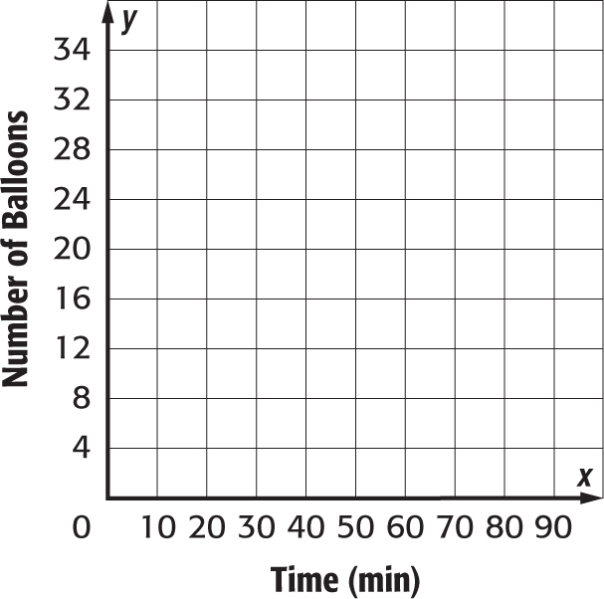
Time (min) | 10 | 20 | 30 | 40 | 50
Balloons | 3 | 12 | 15 | 16 | 21

a. Construct a scatter plot of the data. Then draw and assess a line that seems to best represent the data.

b. Use the line of best fit to make a conjecture about the number of balloons she will have blown up at the end of 70 minutes.

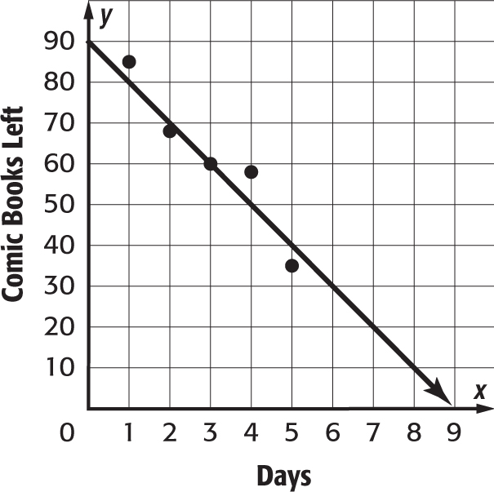
2. COMIC BOOKS Sidney is selling his comic book collection on the Internet. The scatter plot shows how many comic books he has left at the end of each day.

a. Write an equation in slope-intercept form for the line that is drawn.

b. Use the equation to make a conjecture about the number of comic books he will have at the end of the seventh day.

3. ICE RINK Maury has an ice rink in his back yard. The scatter plot shows the thickness of the ice relative to the temperature.
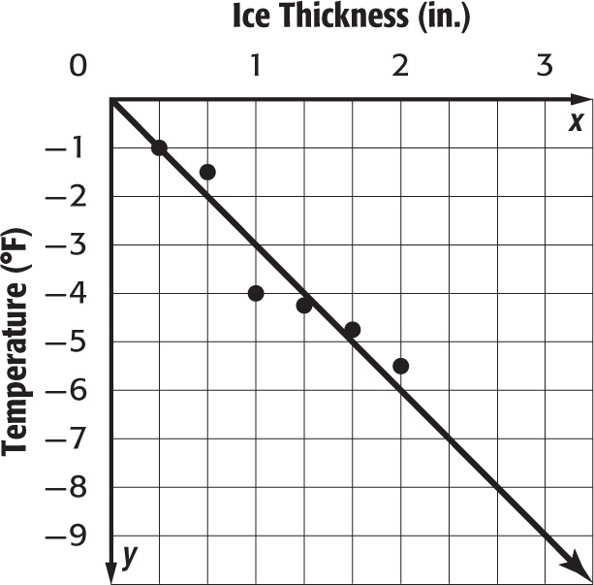

a. Write an equation in slope-intercept form for the line that is drawn.

b. Use the equation to make a conjecture about the $\frac{1}{3}$ inches.

